**ASSIGNMENT - 2**

**MODULE 6**

**BUCKET VERSIONING**

**DONE BY  
RANJITH KUMAR**

**Tasks To Be Performed:**

1. Enable versioning for the bucket created in task 1.

2. Re-upload any 2 files already uploaded to verify if versioning works.

STEP 1 : Open S3 from aws services

STEP 2 : Select the bucket from the task1

STEP 3 : Select properties > bucket versioning > edit

STEP 4 : Enable the bucket version and save the changes to the bucket

STEP 5 : Again upload the two files(jpg & pdf) already stored in the bucket

STEP 6 : Select the pdf and jpg objects in the bucket

STEP 7 : Select versions

STEP 8 : Version has been display in the version window for jpg & pdf objects

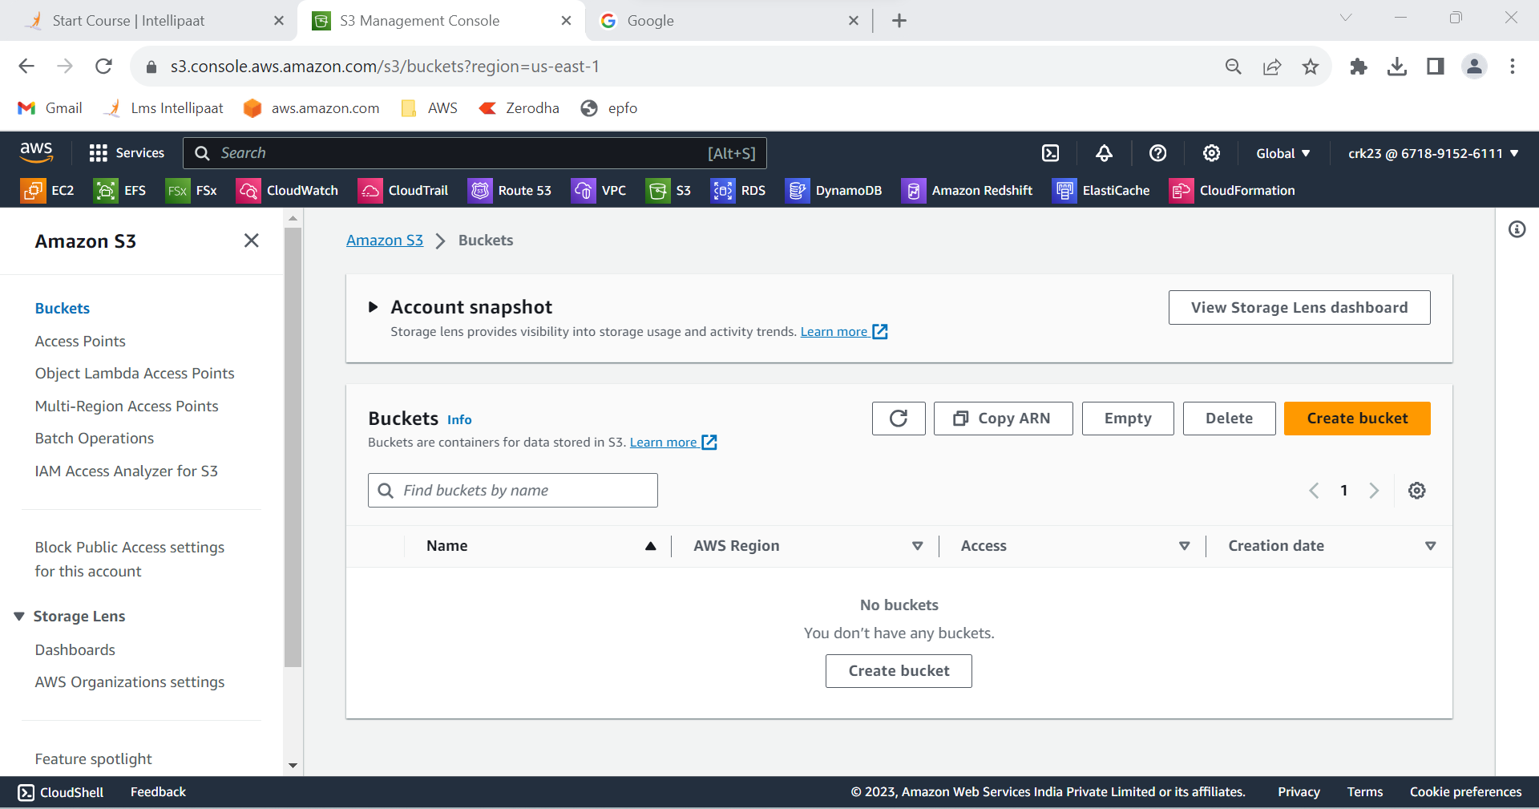

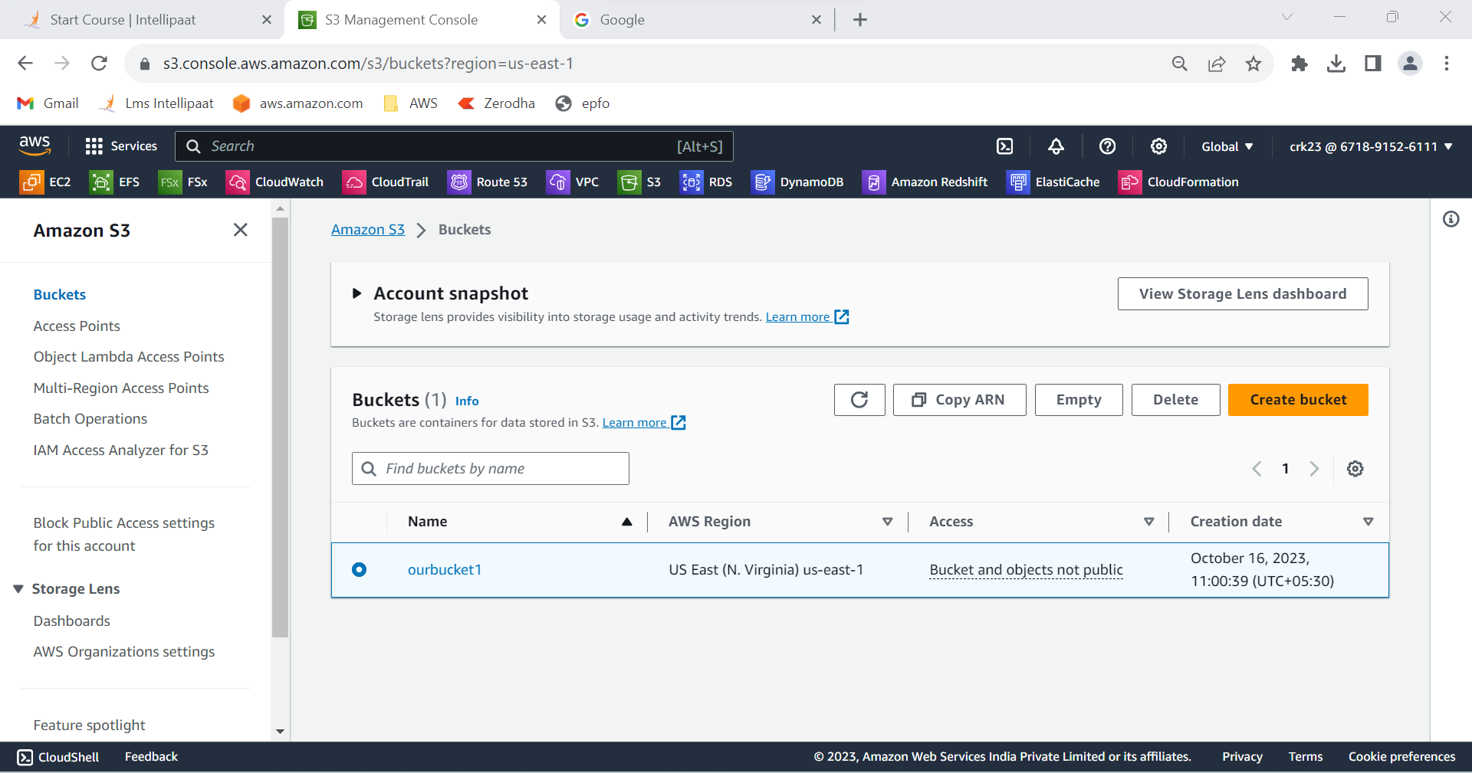

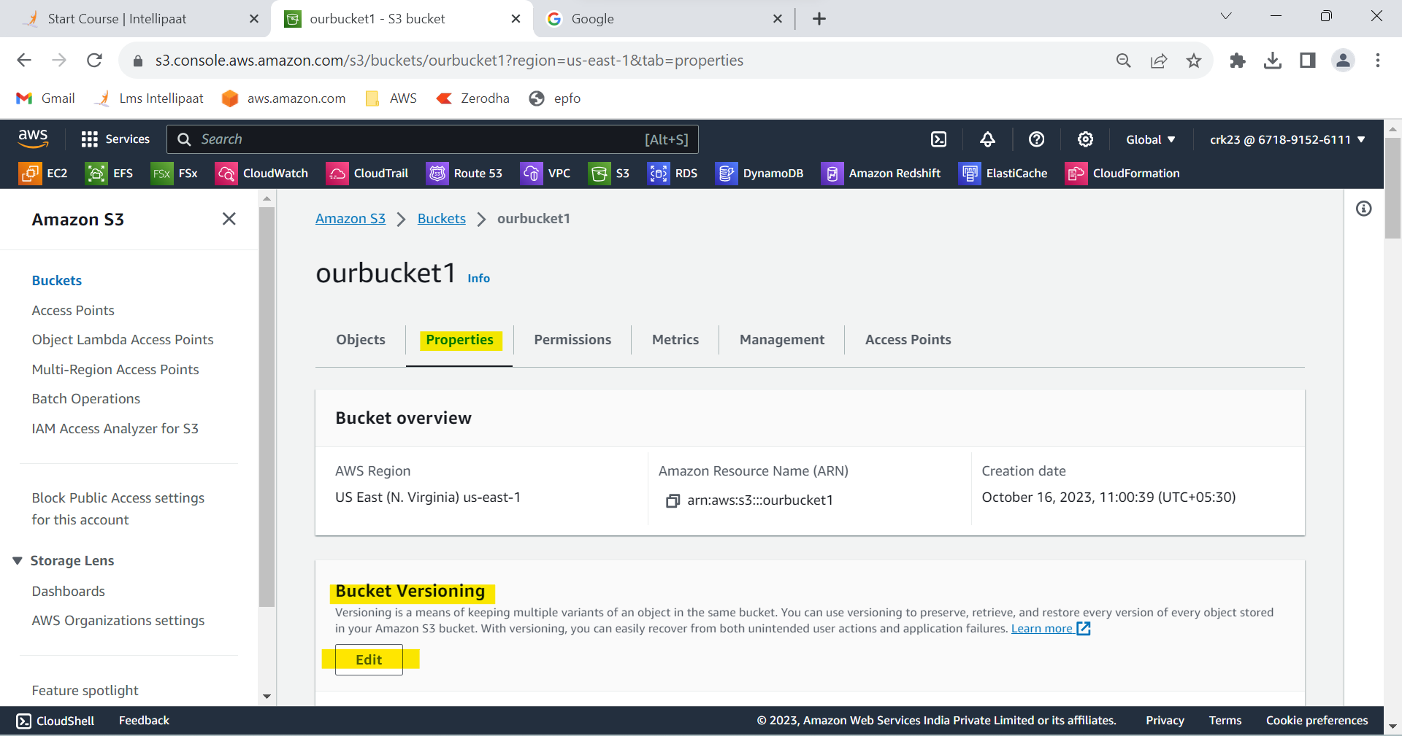

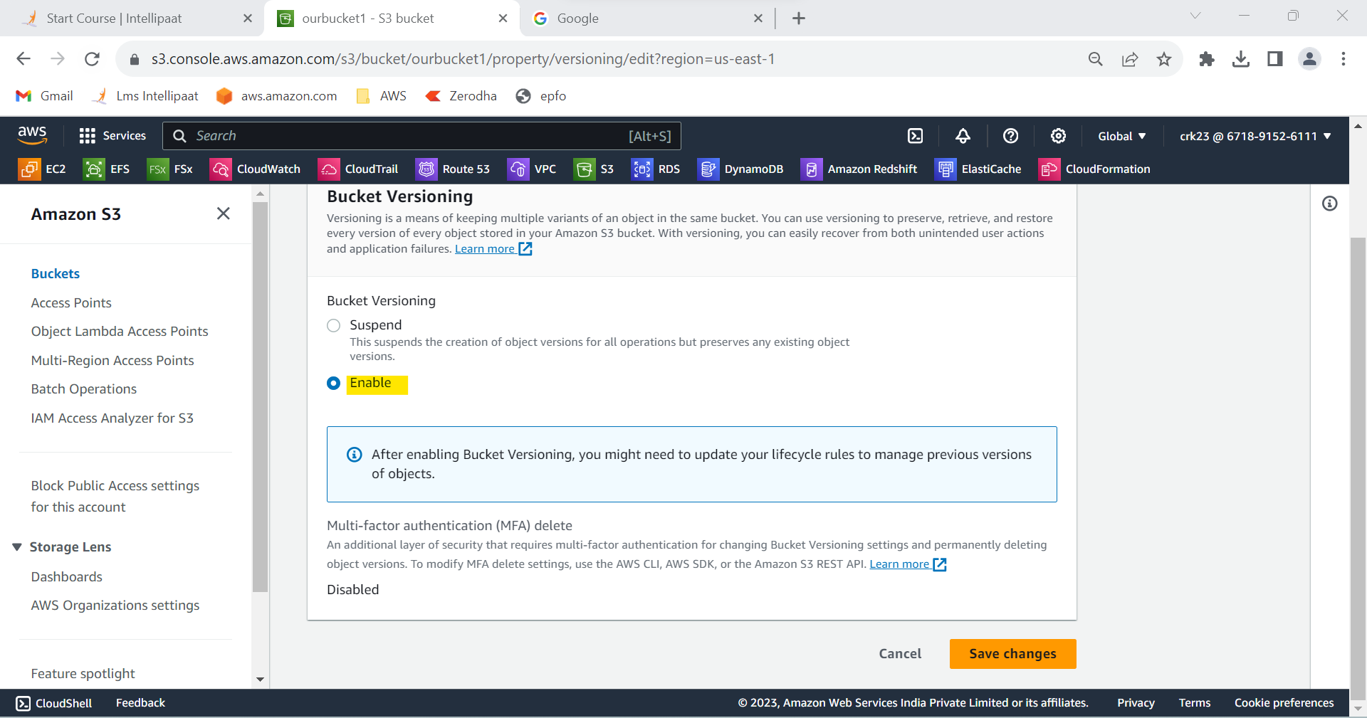

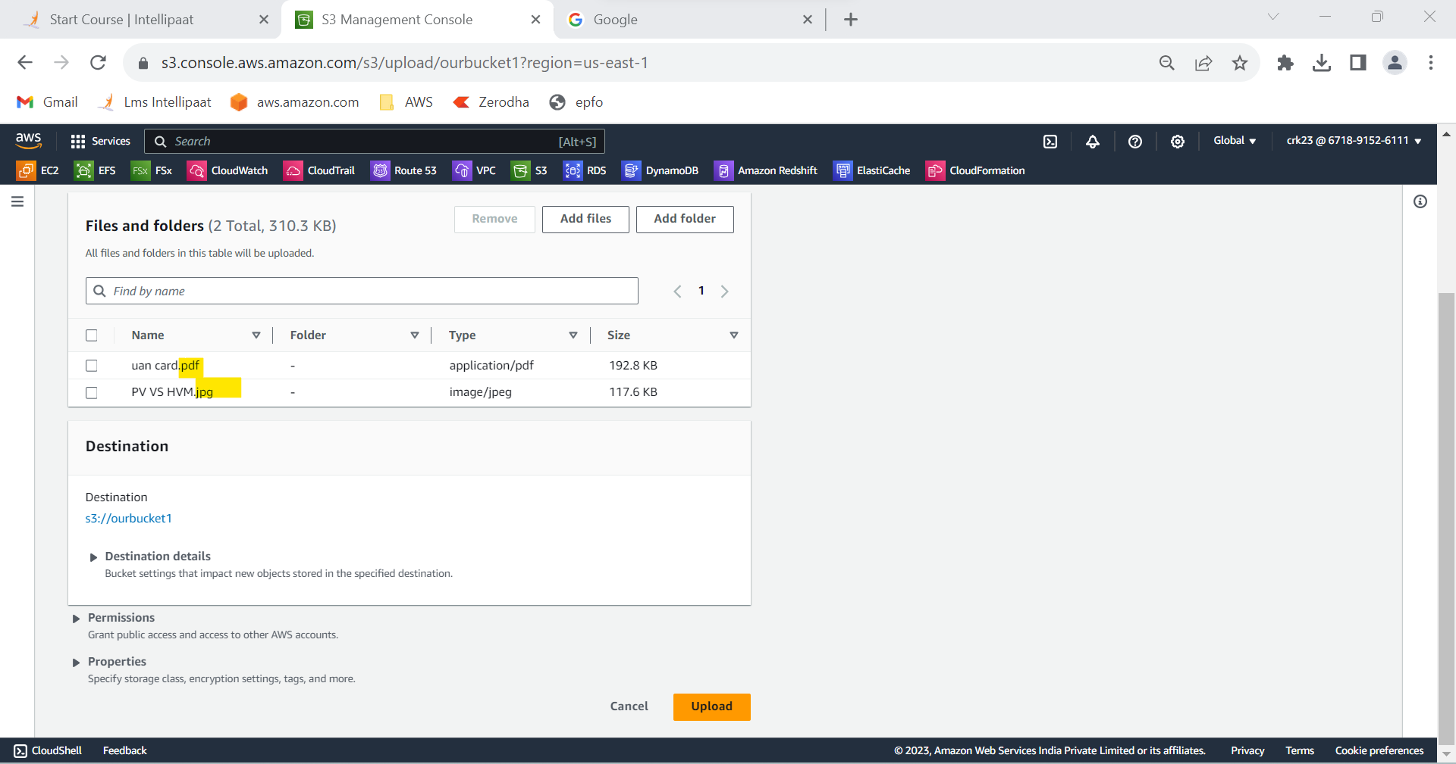

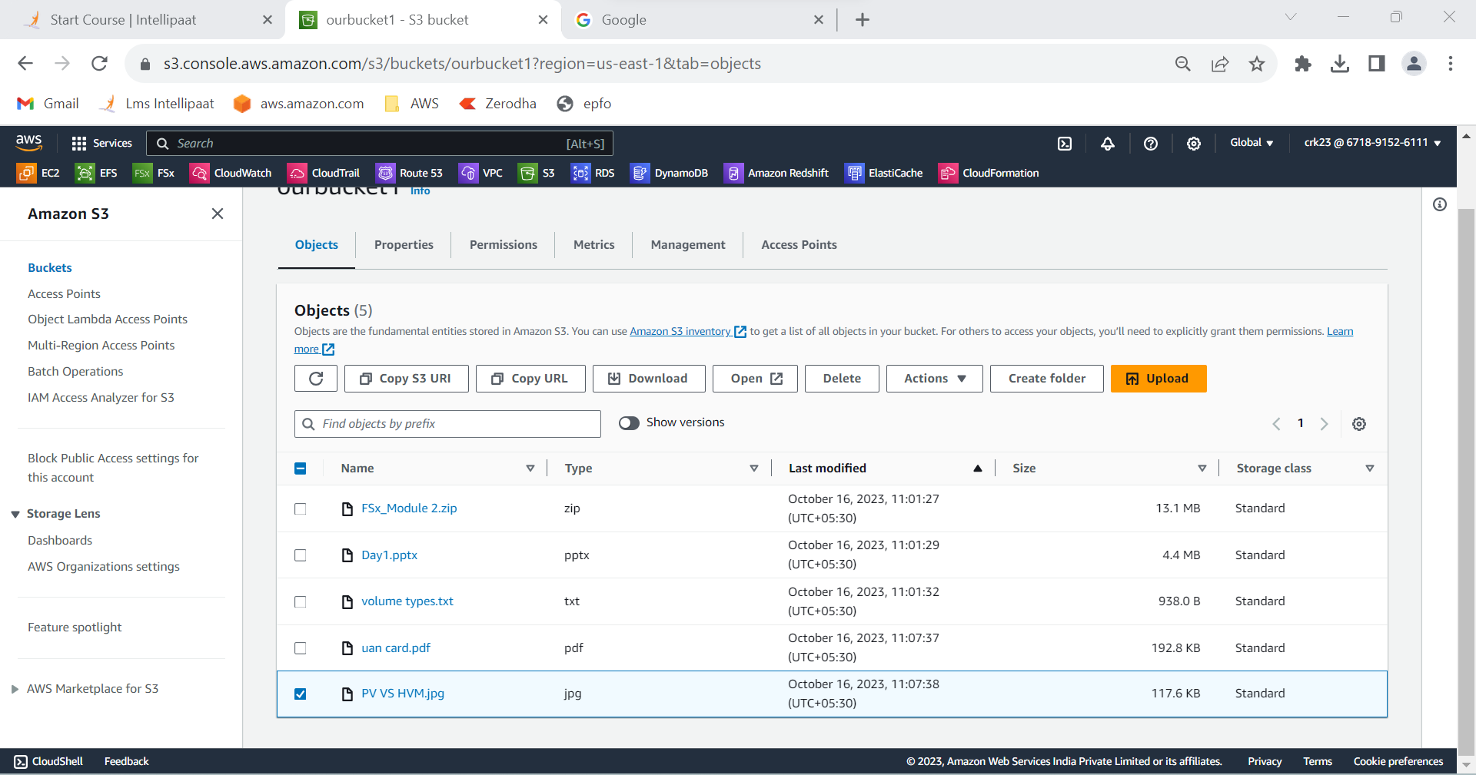

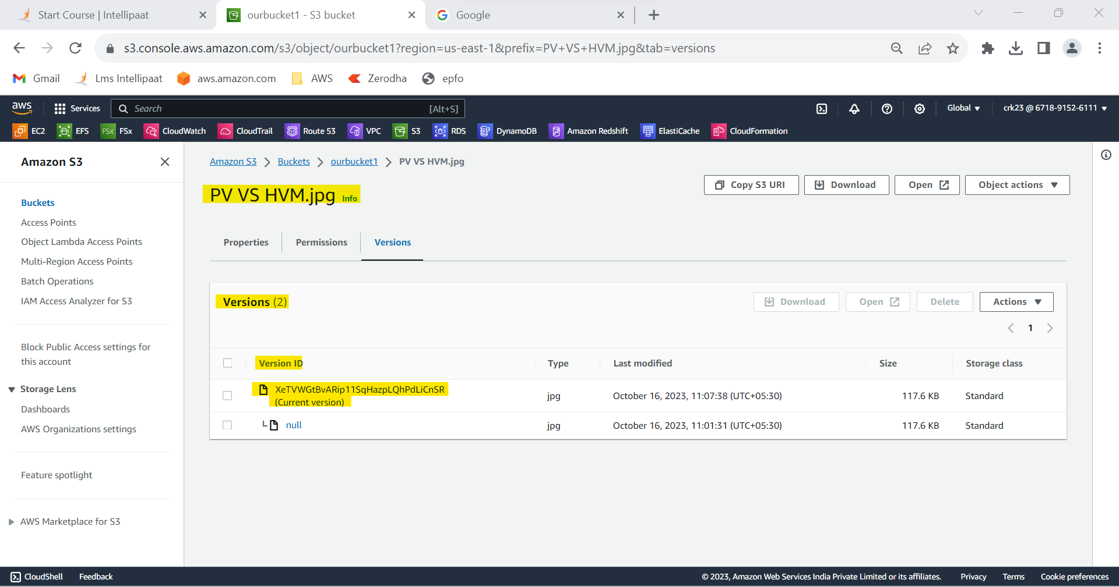

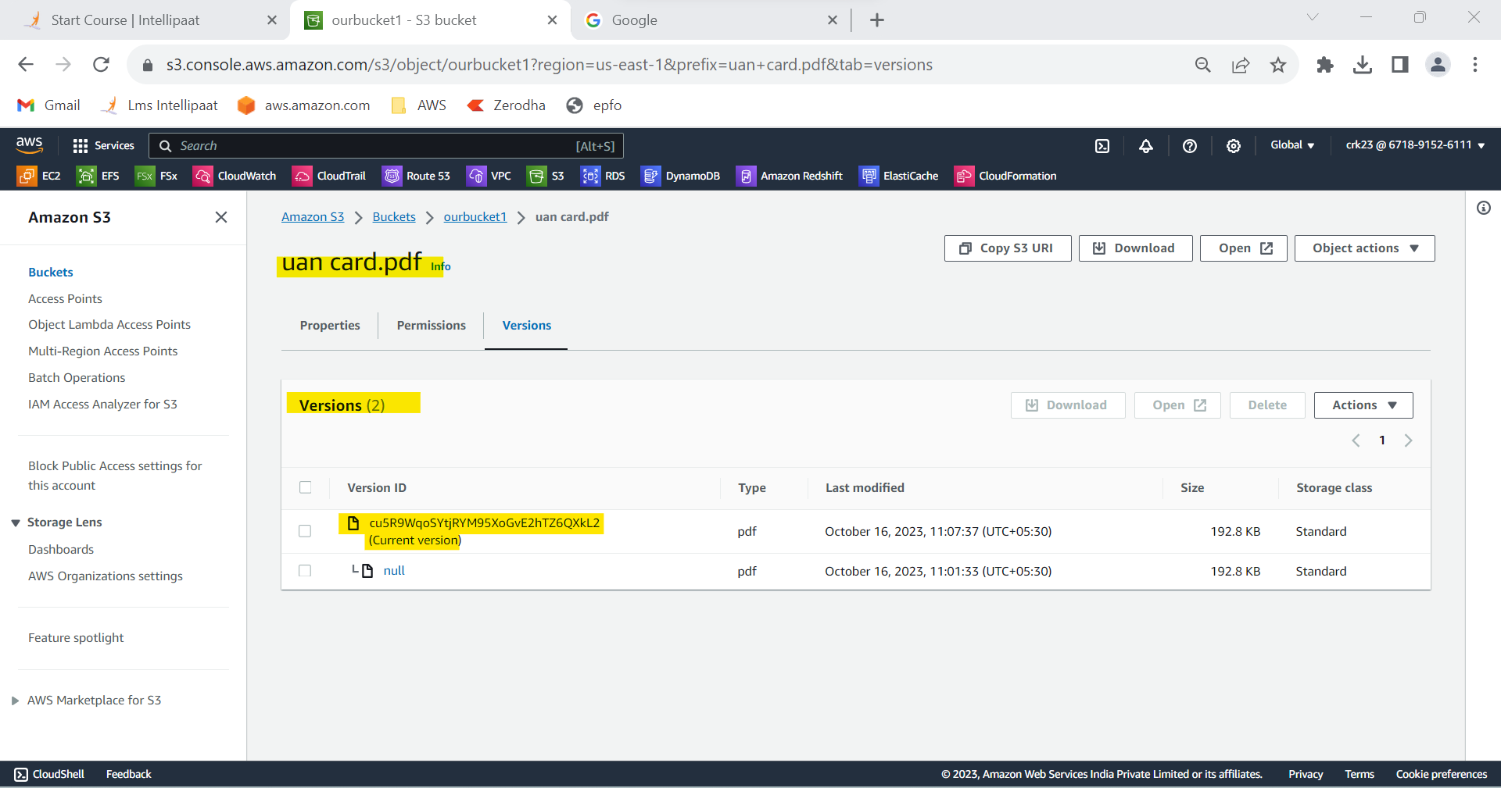

**OUTPUT :**

Enabled bucket version of our bucket1 from the task1 and reuploaded the files and check versiona enabled.